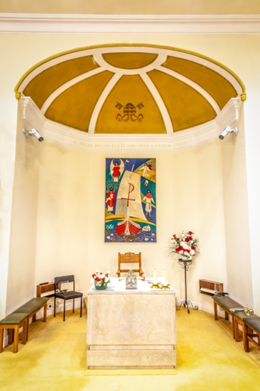
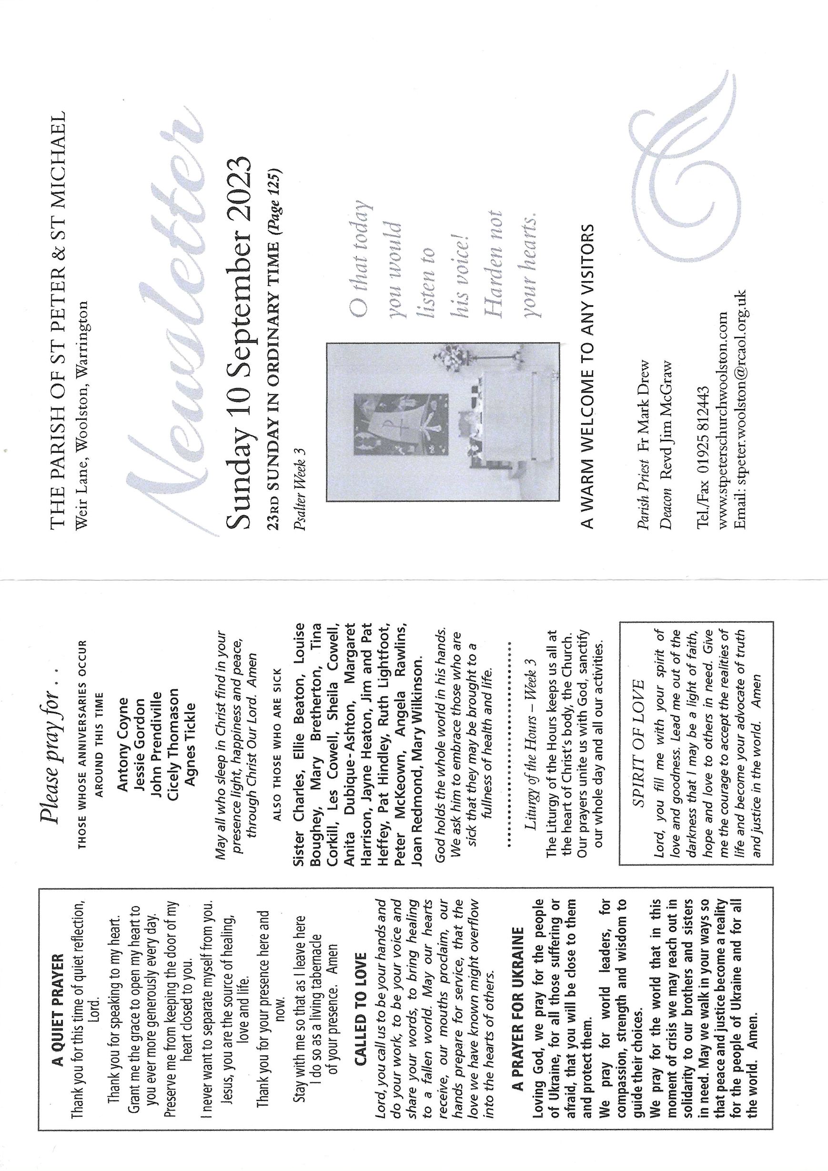
Children’s Liturgy
A number of us have expressed a desire to see the return of the Liturgy and it was discussed at last week’s SPAM meeting. However, for it to happen we need a group of people to work together. Resources are already available for delivery of the Liturgy with weekly topics, activities and support packages, but we need volunteers to deliver it.

If you are willing to be involved in this process, please could you leave your name and contact number with Fr. Mark, Deacon Jim or to the parish email address. If we can build a team to deliver, we will be helping our children to better understand their faith and become active members of the parish in the future – a goal which we are all hoping and striving towards.

Creation Time 2023
This year Creation Time adopts the title Let Justice and Peace Flow and runs from Friday 1 September to 4 October (the feast day of St Francis of Assisi). It’s not too late to send in photographs for this theme for use on the church website and Mass presentations during this period. Please email your photos in jpeg format (landscape orientation) of landscapes, seascapes, places of interest, still life etc., but not including people, for the parish website at: stpeter.woolston@rcaol.org.uk
The first of your submissions is used in today’s Mass. Also, please check out our Creation Time page on the website. It’s under “Other News” for more information on the archdiocese work in this space or the Archdiocese website itself.
Mass Intentions for the week
Date | Time | Feast Day | Intention
Sat  9th Sep | 18.30 | St. Peter Clava | Ann Duffy
Sun  10th Sep | 11.00 | St. Thomas of Villanova | John Leather; Stan Wright; Joseph Durkan
Mon  11th Sep |  | St. Cyprian | No Mass
Tue  12th Sep | 09.30 | Most Holy Name of the Blessed Virgin | No Mass
Wed  13th Sep | 19.30 | St. John Chrysostom | People of the Parish
Thu  14th Sep |  | Exaltation of the Holy Cross | No Mass
Fri  15th Sep | 09.30 | Our Lady of Sorrows | No Mass
Sat  16th Sep | 18.30 | St. Cornelius | Thanksgiving for successful treatment
Sun  17th Sep | 11.00  12.30 | St. Robert Bellarmine  Baptism | Frank Sands  Zachary Christopher Simms
Macmillan Coffee morning
Our coffee morning in support of Macmillan will be on Friday 29th September at 10.00 am after morning Mass.
Bakers can bring cakes on the day, raffle tickets are on sale after every Mass. Please check out the notice in the church porch.
PARISH 100 CLUB
The September draw will take place this Sunday (10th) after 11.00 Mass. Numbers are still available, however a few numbers have missed the last couple of draws as subscriptions have not been paid. Please remember:

You have to be in it to win it, and to win it you have to pay up!
Monthly Working Party
The next maintenance working party will be on Tuesday 12 September after Mass. Please feel free to join in and help keep our church surroundings as nice as they are.

- Fr. Mark and Deacon Jim are both away this weekend. Masses will be said by Fr. Austin in their absence.
Warrington Foodbank
Any surplus food items are welcomed, especially cooking sauces for pasta or curry, tinned food, cordial or fruit juices and long-life milk. Your donations can be left in the crate in the church porch and will certainly help those less fortunate.
Thank you for your help – it is very much appreciated.
Catholic education Service
There is a second collection this week in aid of the Catholic Education Service. Please respond with your usual generosity.
Rest in Peace
It is with great sadness that we announce the passing of Patricia Claire Davies (Claire).
Her funeral will be held in church on Monday 18th September at 10.15 followed by committal at Walton Lea Crematorium at 11.20.
Priests in Concert
To celebrate the centenary of the Lourdes Pilgrimage, The Priests will be live in concert at the Metropolitan Cathedral on Thursday 12th October at 7.30.p.m. Please see the information sheet on the notice board in the porch to register your interest.
Thicket Priory Visit
If you would like to join our parish away-day retreat to Thicket Priory Convent on Saturday 4th November, there is a list in the porch on the notice board to register your place. Seats are filling fast!
In the past it has been a most enjoyable and fulfilling visit.

Last Week’s Offertory - £367.53
Thank you!
Remember that sometimes, silence is the best answer.

